Aim: Download and install wireshark and capture icmp, tcp, and
http packets.

What is Wireshark?
Wireshark is a free and open-source network packet analyzer used to capture, view, and analyze data packets traveling through a network. It helps users understand how devices communicate and how information moves across a network.
It is commonly used by network administrators, cybersecurity professionals, and students to troubleshoot network problems, monitor traffic, and learn about network protocols.
Wireshark can capture and analyze protocols such as TCP, UDP, HTTP, DNS, IP, and ARP, making it useful for studying network communication and finding network issues.

Steps to Download Wireshark in Linux

Step 1: Open Terminal
Open the Terminal application in your Linux system.

Step 2: Update Package List
Update the system package list using the command: sudo apt update

Step 3: Install Wireshark
Install Wireshark by running: sudo apt install wireshark

Step 4: Allow Packet Capturing for Normal Users
During installation, a prompt will appear:
"Should non-superusers be able to capture packets?"
Select: Yes
This allows normal users to capture network packets without using administrator privileges.

Step 5: Add User to Wireshark Group
Run the following command: sudo usermod -aG wireshark $USER

Step 6: Apply Changes
Log out and log in again, or run: newgrp wireshark

Step 7: Launch Wireshark
Start Wireshark using: wireshark

Step 8: Start Capturing Packets
- Select your active network interface:
○ Wi-Fi
○ Ethernet
- Click the Start Capture button.
- Wireshark will begin capturing and displaying network packets.
Screenshots:
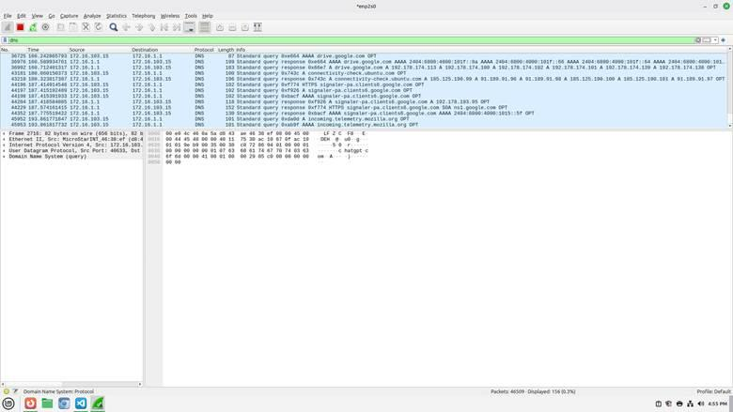

Conclusion:
Wireshark was successfully downloaded, installed, and used to capture network packets. The experiment helped in understanding the analysis of ICMP, TCP, and HTTP packets and how data is transmitted over a network. Wireshark is a useful tool for monitoring, troubleshooting, and learning network communication.

